Neosha Allen
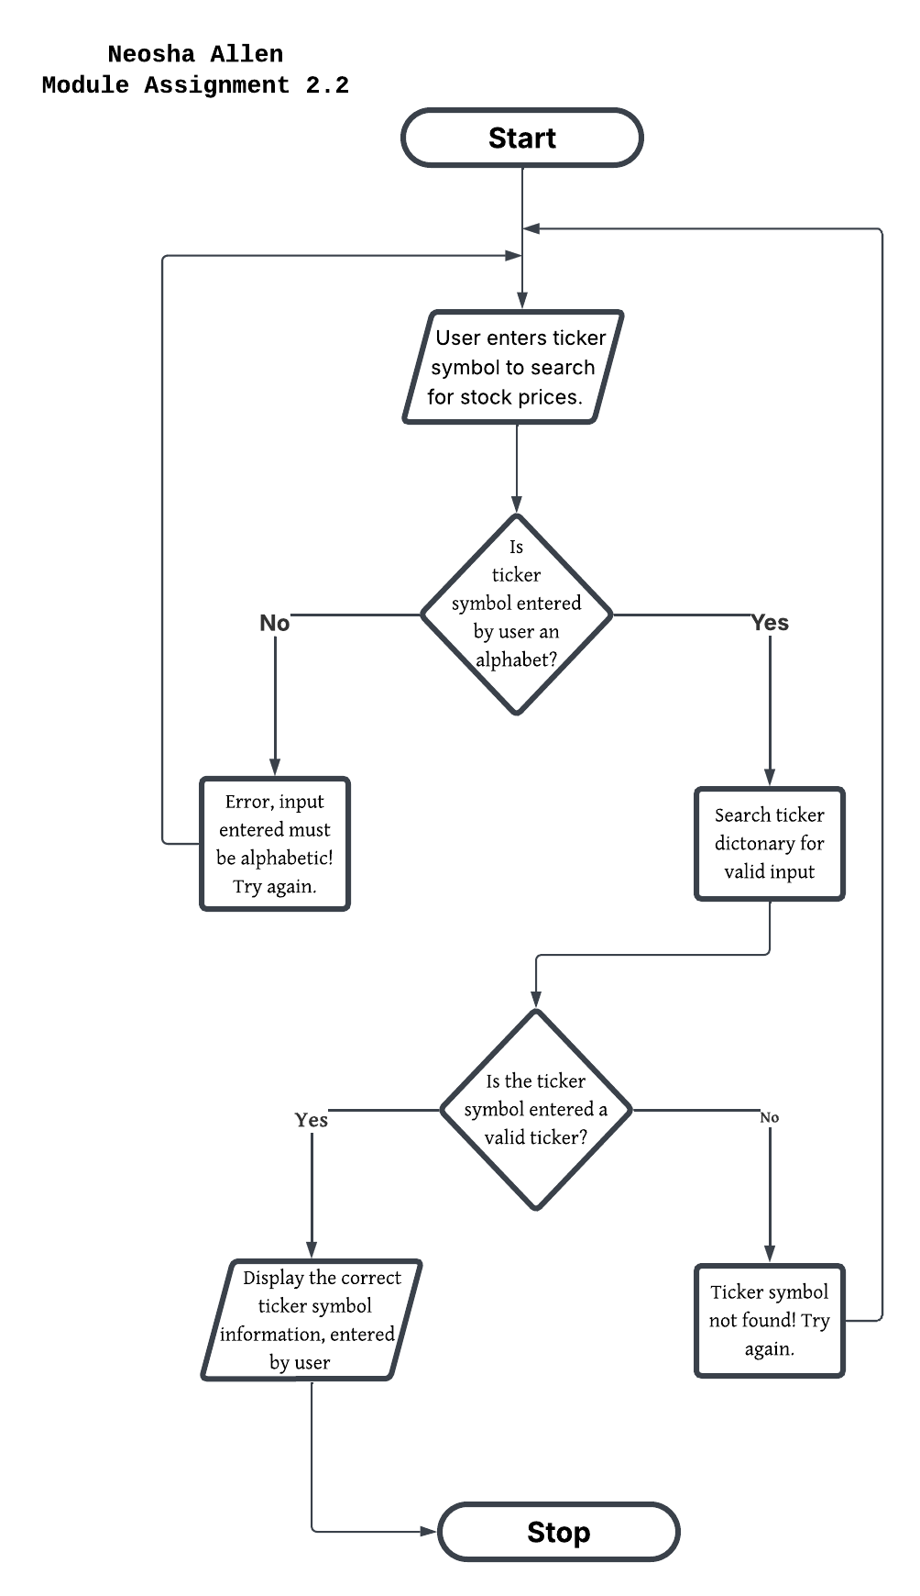
Module Assignment 2.2

